CO2 ASSESSSMENT TOOL 2
CSA1305-TOC
K Gayathri-192311448

1. Design the Regular Expression for the Language Represented by the Given Automaton
Given Automaton
States:
- q0 → Start State
- q1 → Intermediate State
- q2 → Final State
Transitions:
- q0 → q1 on 0,1
- q1 → q2 on 0,1
- q2 → q1 on 0,1
Step 1: Analyze the DFA
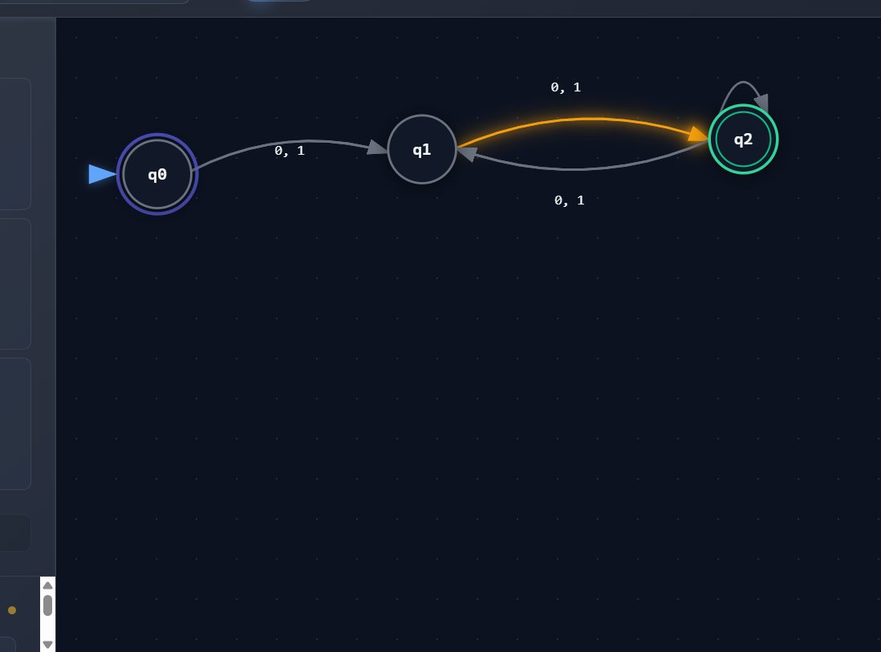
To reach the final state:
- One symbol moves from q0 to q1.
- Another symbol moves from q1 to q2.
After reaching q2, the automaton alternates between q2 and q1 on every input symbol.
Hence accepted strings have even length (minimum length = 2).
Examples Accepted:
00
01
10
11
0011
1100
1010
111100
Rejected:
0
1
000
111
101

Regular Expression
Since every symbol may be either 0 or 1,
the regular expression is
$$\boxed{{\left(\left(0+1\right)\left(0+1\right)\right)}^{+}}$$
or equivalently,
$$\boxed{\left(0+1\right)\left(0+1\right){\left(\left(0+1\right)\left(0+1\right)\right)}^{*}}$$

Applications
- Binary protocol validation
- Digital communication
- Network packet verification
- Lexical analysis

Conclusion
The automaton accepts all binary strings having even length, represented by
$${\left(\left(0+1\right)\left(0+1\right)\right)}^{+}$$
2. Grammar
Given
S → aSc | T | U | ε

T → bTc | ε

U → aUb | ε

(A) Language Defined
Production 1
S → aSc
Generates
aⁿcⁿ\
Production 2
T → bTc
Generates
bⁿcⁿ

Production 3
U → aUb
Generates
aⁿbⁿ

Hence,
$$\boxed{L=\left\{a^{n}c^{n}\right\}∪\left\{b^{n}c^{n}\right\}∪\left\{a^{n}b^{n}\right\}∪\left\{ϵ\right\}}$$

(B) Derivation Tree for aaabbc
The string
aaabbc
cannot be produced.
Reason:
The grammar produces
aⁿcⁿ

or

bⁿcⁿ

or

aⁿbⁿ
but never
aaa bb c
Therefore
No derivation tree exists.

(C) Ambiguity
Definition:
A grammar is ambiguous if one string has more than one parse tree.
Here every production generates a different language.
No string has two different parse trees.
Therefore
$$\boxed{\text{Grammar is NOT Ambiguous}}$$
3. Design an ε-NFA for
00*1*11*0
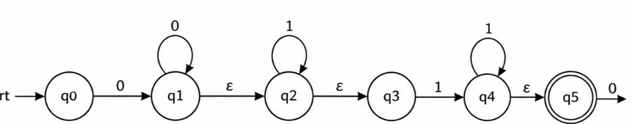

Regular Expression
0 0* 1* 1 1* 0
Simplified
0+ 1+ 0

ε-NFA Construction
States
q0 → q1 → q2 → q3 → q4
Transitions
q0 --0--> q1

q1 --0--> q1

q1 --ε--> q2

q2 --1--> q2

q2 --1--> q3

q3 --1--> q3

q3 --0--> q4
Final State
q4

Examples
Accepted
010
0010
0001110
0011110
Rejected
100
1110
000

Applications
- Compiler lexical analyzer
- Pattern matching
- Intrusion detection
4(i) Show that if L₁ and L₂ are Regular then (L₁+L₂) is Regular
Closure Property
Regular languages are closed under Union.
Suppose
L₁
is recognized by DFA M₁
and
L₂
is recognized by DFA M₂.
Construct the product DFA
Q = Q₁ × Q₂
Accept if either DFA accepts.
Therefore
$$\boxed{L_{1}∪L_{2}\text{ is Regular}}$$

Applications
- Spam filtering
- Firewalls
- Search engines
- Compiler scanners

4(ii) Is
$$\left\{a^{p}∣p\text{ is prime}\right\}$$
Regular?

Answer
No.

Pumping Lemma Proof
Assume
L
is Regular.
Take
w=a^q
where
q
is prime and larger than pumping length.
Split
w=xyz
where
|xy|≤p
Hence
y=a^k
Pump
i=2
Length becomes
q+k
(or by choosing an appropriate pumping count, a composite length is obtained), which is not guaranteed to remain prime.
Contradiction.
Therefore
$$\boxed{\left\{a^{p}∣p\text{ prime}\right\}\text{ is NOT Regular}}$$ 5. DFA Minimization

Step 1
Separate
Final
{q1,q2,q4}
Non-final
{q0,q3,q5}

Step 2
Compare transitions.
Equivalent states are merged if every transition leads to equivalent states.
For the given DFA, after partition refinement the equivalent pair is:
$$\boxed{q_{1}≡q_{4}}$$
(All other states remain distinguishable.)

Step 3
Merge
q1
and
q4
into one state.

Minimized States
q0

q3

(q1,q4)

q2

q5

Advantages
- Reduced memory
- Lower hardware cost
- Faster execution
- Less power consumption
- Efficient embedded implementation

Applications
- ATM machines
- Smart cards
- IoT devices
- Embedded controllers
- Digital communication systems

Conclusion
The minimized DFA recognizes the same language as the original DFA but with fewer states, resulting in simpler hardware and faster execution.

